ROOF ACCESSORIES 07 72 00
HANGERS AND SUPPORTS FOR COMMUNICATION SYSTEMS 27 05 29

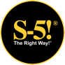
S-5! GRIPPERFIX® Utility System

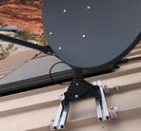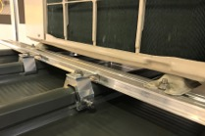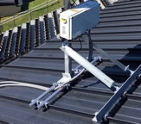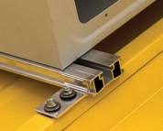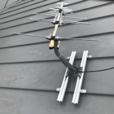
Satellite Dishes & POS Systems
- Manufacturer
S-5! ®
Metal Roof Innovations, Ltd.
500 W. Highway St.
Iowa Park, TX 76367
Technical Assistance:
888-825-3432
support@s-5.com
https://s-5.com/support-information/
architecturalsales@s-5.com
Website: www.s-5.com

- Product Description
BASIC USE:
THE S-5! GRIPPERFIX is a convenient method for attaching rooftop ancillaries without compromising roof integrity, warranties or safety. Its components provide a simple, secure and economical method to attach roof-mounted utilities with tested, engineered, direct attachment of struts, clamps or brackets to a metal roof’s seams or ribs. The GRIPPERFIX is compatible with all S-5! clamps and is warranted** for the life of the roof.

ADVANTAGES:
- The GRIPPERFIX can be easily installed on exposed-fastened and standing seam metal roofs.
- The GRIPPERFIX does not require field-applied sealants.
- The GRIPPERFIX allows free flow of rainwater under the system.
- The GRIPPERFIX is compatible with all S-5! standard or Mini clamps. Only one tool is needed to complete installation.
- The GRIPPERFIX does not penetrate the standing seam metal roof panel nor void the roof manufacturer’s warranty.
- The S-5! attachment clamp does not void the roof manufacturer’s warranty. All major metal roof manufacturers endorse S-5! Attachments.
- The round-point setscrews “dimple” the seam material creating a mechanical interlock within the clamp.
- S-5! has conducted more than 3,000 load tests on 500+ different metal roof profiles, materials and gauges to enable credible site-specific and panel-specific engineering. The resulting ISO 17025 accredited lab-tested and published holding strength is the first (and only) recognized by the ICC-ES.

Version071321
© Copyright 2021 Metal Roof Innovations, Ltd.

SYSTEM COMPONENTS:
Exposed Fastened Roof Components
- Gripper Strut. Available in 26” and 52” lengths.
- GF-26 – Most satellite dish applications.
- GF-52 – Most HVAC applications.
- Damper/Leveling Pad – Optional. EPDM rubber; keyhole slot for insertion over bolts.
- EF Tab with factory-applied EPDM rubber gasket designed to interlock securely with strut.
- M8 1.25 x 16, 20, or 40 mm bolt.
- M8 Hex flange nuts.
- Piercing fastener with EPDM “double seal” performance rubber gasket. Designed to pierce and not leave swarf.
- For installation on most exposed-fastened metal roofs (trapezoidal and corrugated).

Standing Seam Roof Components:
- Gripper Strut. Available in 26” and 52” lengths.
- GF-26 – Most satellite dish applications.
- GF-52 – Most HVAC applications.
- Damper/Leveling Pad – Optional. EPDM rubber; keyhole slot for insertion over bolts.
- CF Tab with slotted hole for adjustment designed to interlock securely with strut.
- M8 1.25 x 16, 20, or 40 mm bolt.
- M8 Hex flange nuts.
- S-5! clamps and Mini clamps – sold separately due to the variety of attachment needs. Find specific metal roof manufacturer product and profile test data at https://s-5.com/load-tests/

3. Composition & Materials
Standard components are manufactured from high-tensile, certified raw materials (6061 T6 alloy structural aluminum), hardware is certified 300 series (18-8) stainless-steel.

The GRIPPERFIX is attached to roof with aluminum S-5! Mini clamps or S-5! clamps, which are compatible with painted or unpainted G-90 galvanized steel, bare or painted Galvalume®, Galvalume Plus®, Zincalume®, Zincalume Plus®, Acrylume®, Galfan® and Galvannealed® steel, aluminum (painted, bare or anodized), titanium-zinc and stainless-steel metal roofs.

The GRIPPERFIX can be post-anodized or powder coated if desired.*

Inverters & HVAC systems
Other Ancillaries
CSI Masterformat Categories:
07 72 00 Roof Accessories
27 05 29 Hangers & Supports for Communication Systems

4. Technical Data
S-5! products are manufactured to meet or exceed the following standards and test methods:

- Listed to ICC-ES Evaluation Report ESR-3869.

- Aluminum Association (AA) – Aluminum Standards and Data, 2017 Edition.

- ASTM International (ASTM):

- B85-03 – Standard Specification for Aluminum-Alloy Die Castings.

- B221-04a – Standard Specification for Aluminum and Aluminum-Alloy Extruded Bars, Rods, Wires, Profiles and Tubes.

ENVIRONMENTAL CONSIDERATIONS:
Where possible, S-5! products include a high percentage of recycled material, which lessens the environmental impact. Additionally, every S-5! product offers a service life equal to or greater than the roof itself and is 100% recyclable at the end of its extended service life, reducing the solid waste stream.

5. Installation
Detailed installation instructions can be obtained from the manufacturer’s website: https://s-5.com/products/utility-solutions-gripperfix/

Store materials to protect from harmful weather, damage or abuse. Verify acceptable site conditions before proceeding. Deliver materials in manufacturer’s original, unopened, undamaged containers with identification labels intact.

6. Limitations
Any loads imposed upon S-5! clamps and brackets will be transferred to the roof panels to which they are attached. Roof panels must be adequately fastened to the building structure and have sufficient beam strength to resist these loads. When relying on testing load values, setscrew tensions should be verified. Factors of safety should be applied as appropriate. Always install S-5! systems in strict accordance with the manufacturer’s published installation instructions.
*Optional; Not supplied by S-5!

7. Cost & Availability
Contact manufacturer-authorized distributors listed at: https://s-5.com/how-to-buy/ for the most current product prices and product availability.

8. **Warranty
Cost-free Limited Lifetime Warranty: All S-5! products and components are warranted to be free from defects in material and workmanship for the life of the roof. See https://s-5.com/warranty/ for details.

9. Maintenance
When the GRIPPERFIX is properly installed, maintenance is not required. Periodic inspection may reveal errors in installation that should be corrected if found. If cleaning is desired, the system can be washed with mild soap and water followed by a clean water rinse. Do not use ammonia or solutions that contain strong acids or alkalis.

10. Technical Services
Technical assistance, including more detailed information, product literature, test results, project lists, assistance in preparing project specifications, and arrangements for application supervision is available by contacting
S-5! https://s-5.com/support-information/ or the nearest S-5! distributor.

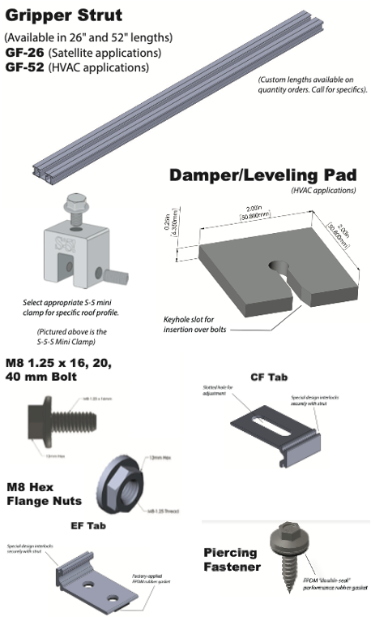

APPROVED

PROJECT NAME________________________________
______________________________________
APPROVED BY___________________________________
PRODUCT SELECTED____________________________
______________________________________
______________________________________

(PLACE STAMP HERE)
Version 071321
© Copyright 2021 Metal Roof Innovations, Ltd.

